**PROJECT REPORT**

**BUILDING A WEBSITE USING CANVA**

|  |  |
| --- | --- |
| **DATE :** | 25 OCTOBER 2023 |
| **TEAM ID :** | NM2023TMID09051 |
| **TEAM LEAD ID –** SOWMIYA M | 6447B190E1EDF84866049ED77CCD28F4 |
| **TEAM MEMBER 1 ID –** CHRISTINA RACHEL R | AFECEA71A57422A82764556BB299AD69 |
| **TEAM MEMBER 2 ID –** BALAGANAPATHY K | 7B36E57953E1BC5B0A140893B4D09EA3 |
| **TEAM MEMBER 3 ID –** ADHITHIYAN A | 5389A570D8B216C97D5427551F47A430 |
| **PROJECT NAME :** | BUILDING A WEBSITE USING CANVA |

**DEFINE PROBLEM / PROBLEM UNDERSTANDING**

To create a website using CANVA for an offline Store and publish it.

**BRAND NAME:** COOKIES AND CREAM BAKERIES

**CATEGORY:** Butter cookies, Chocolate chip cookies ,flavours of cream

**TARGET AUDIENCE:** ALL (Men, Woman, Youths, Teens, Kids, Babies)

**CANVA WEBSITE URL:**

<https://cookiesandcreambakery.my.canva.site/cookiesandcreambakery>

**DOCUMENTATION:**

**NAVIGATION**

Navigate to[**https://www.canva.com/**](https://www.canva.com/)

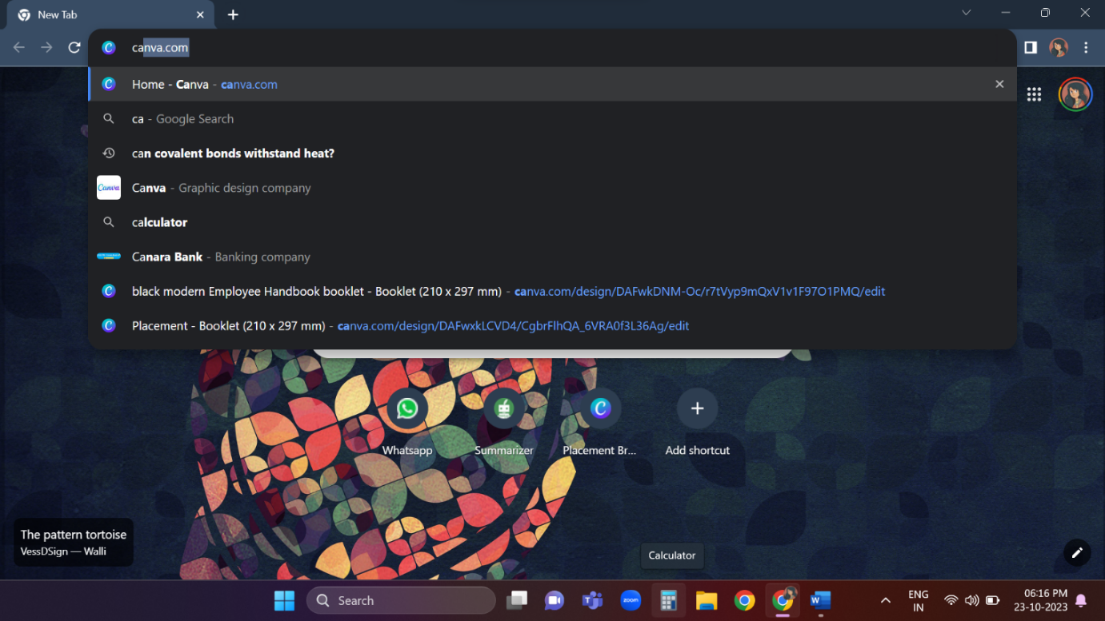

**CREATING DESIGN**

Click "Create a design" As per the picture click on the create design.

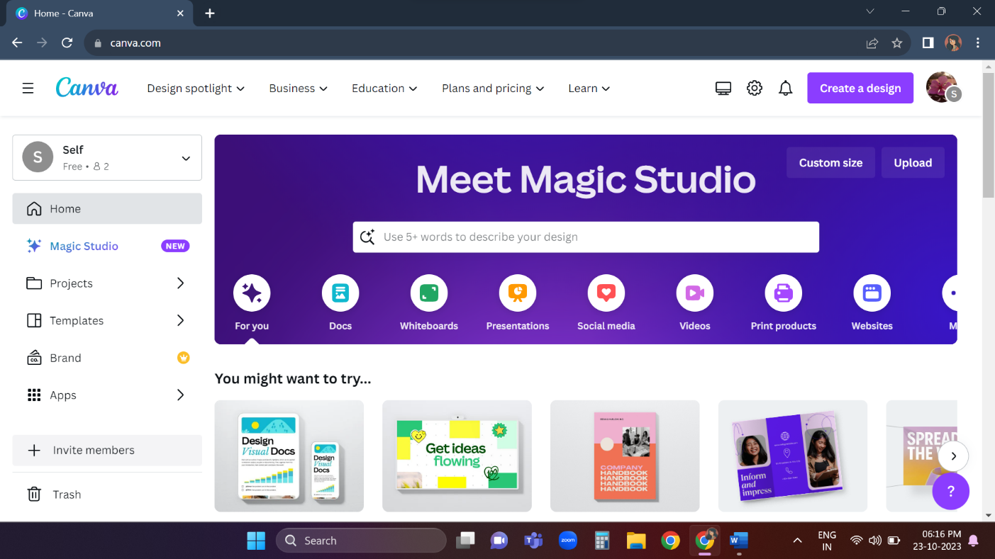

**SEARCH AND CLICK "WEBSITE"**

Search And Click "Website"

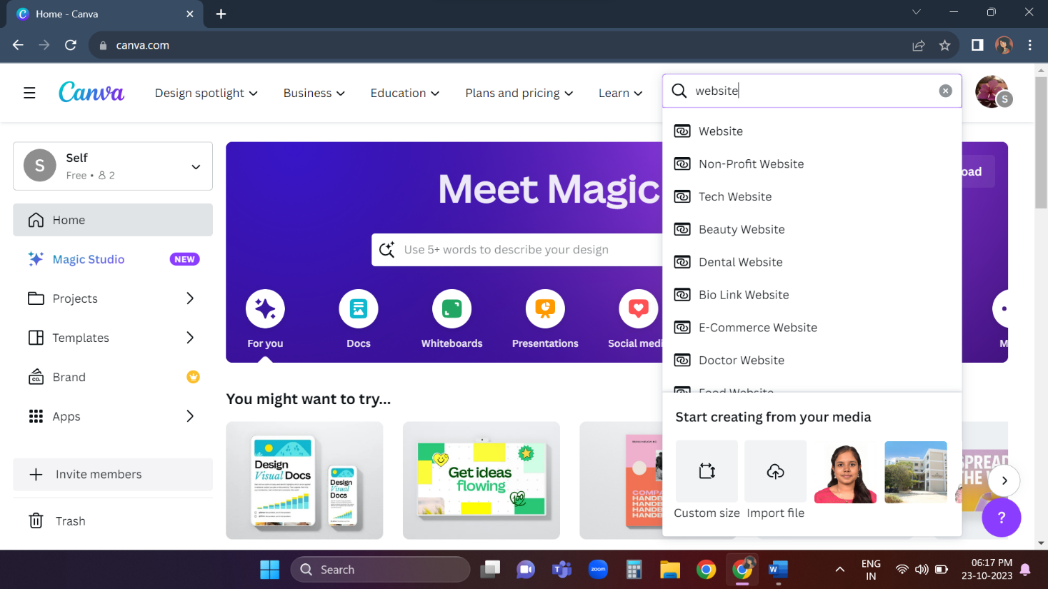

Search And Click "Online Store"

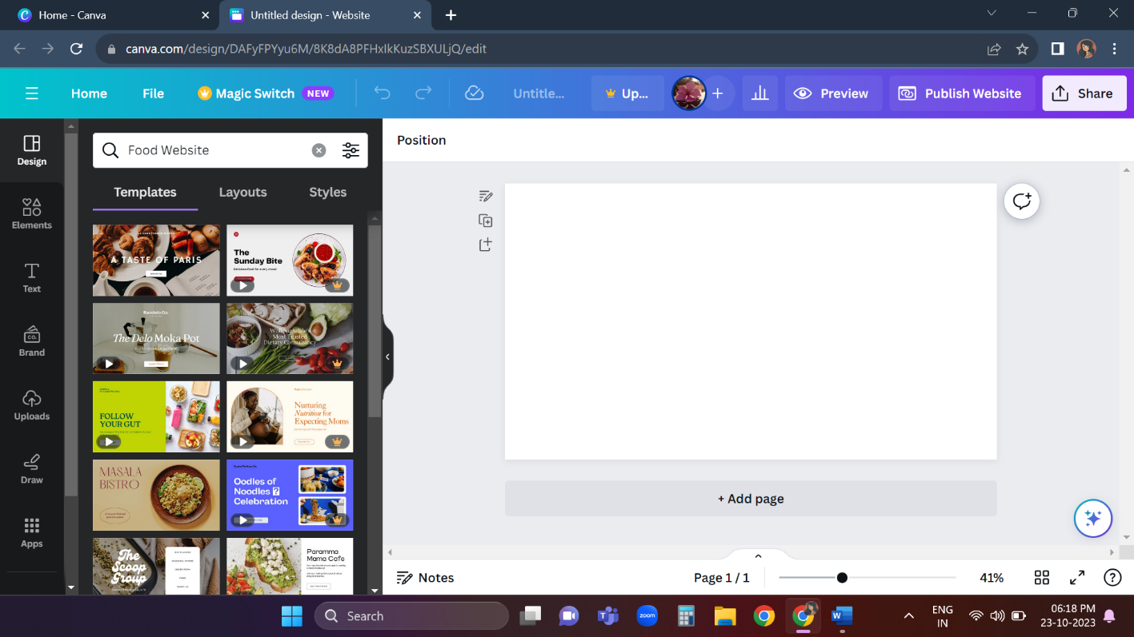

**CHOOSING THE DESIGN**

After entering online store choose a design u like and click on it. select additional templates if you need.

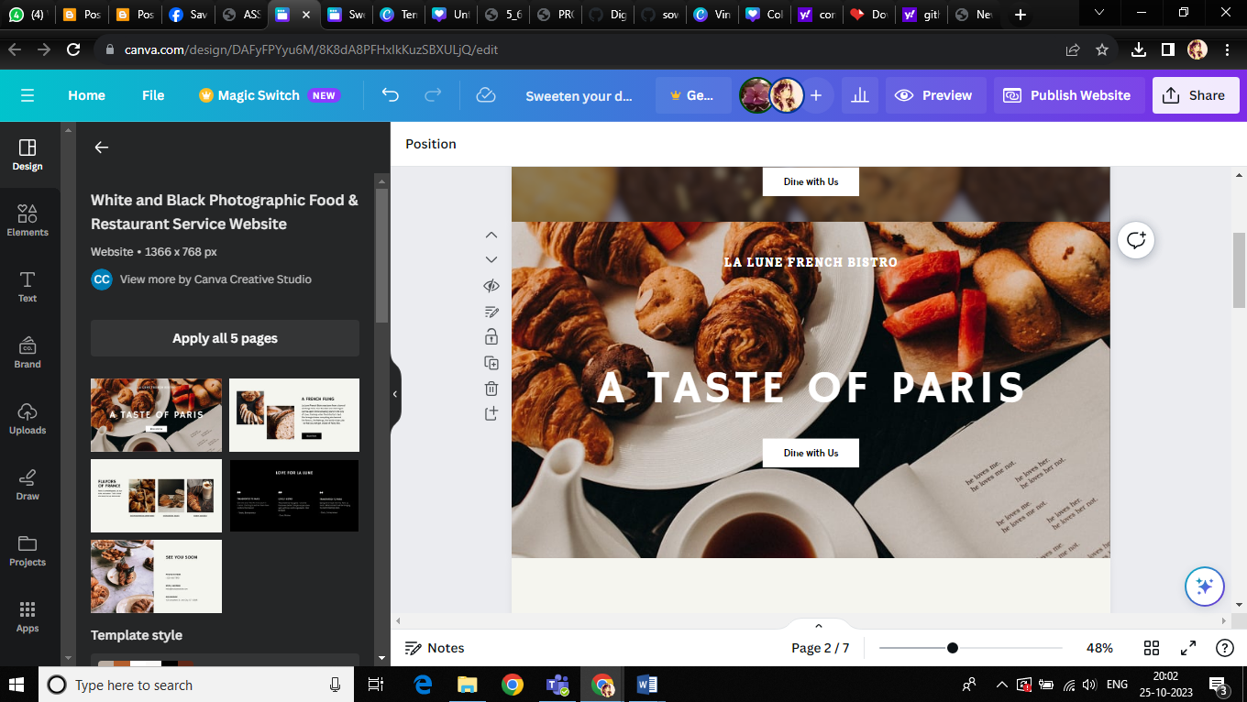

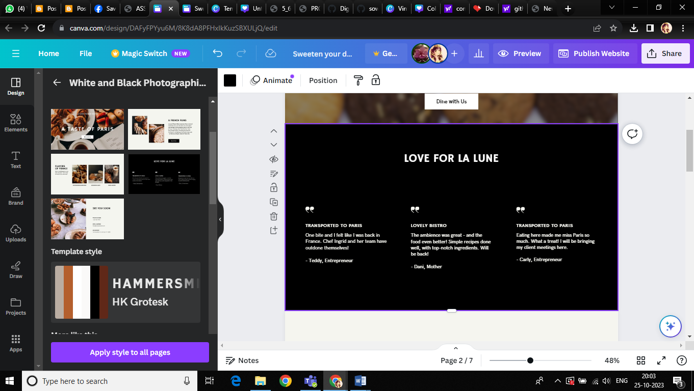

Select "delicious food for every mood" and click duplicate icon and after duplicating it add phone number and place it below order now button.

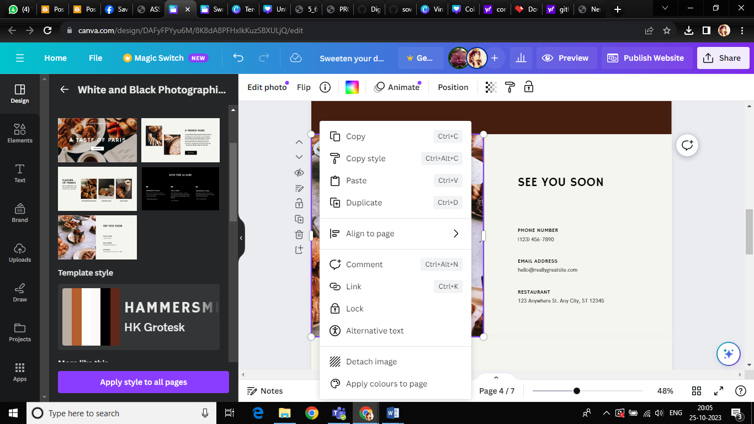

**ADD PHOTOS OR STICKERS**

Add photos or stickers if you need. For that select the page and click the elements on the top of page.

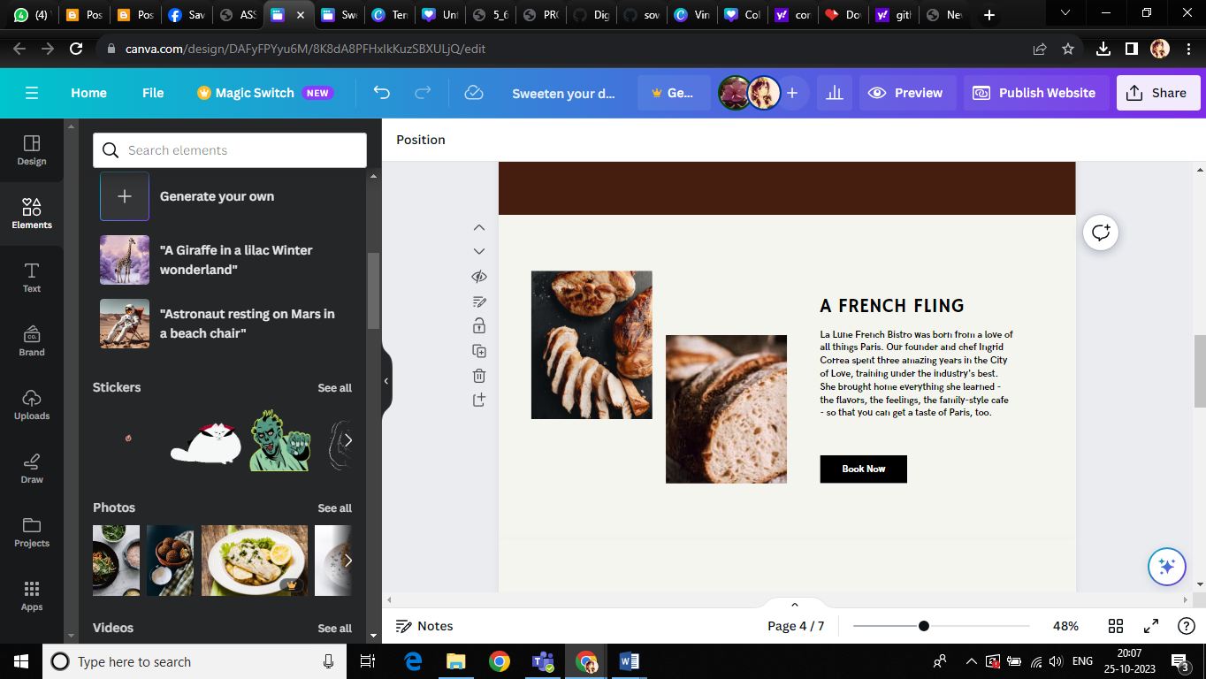

**ADD BRAND FONTS**

Add brand fonts If You Like. Click "Text".

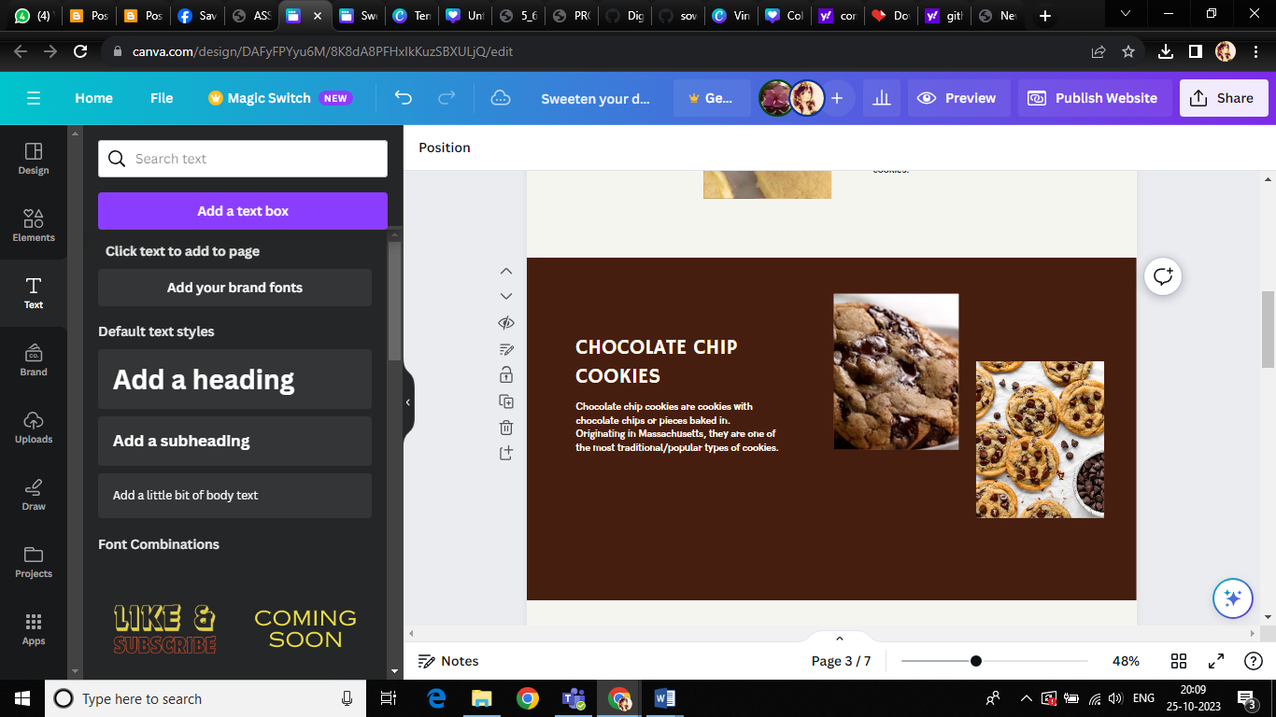

**FINISH EDITING**

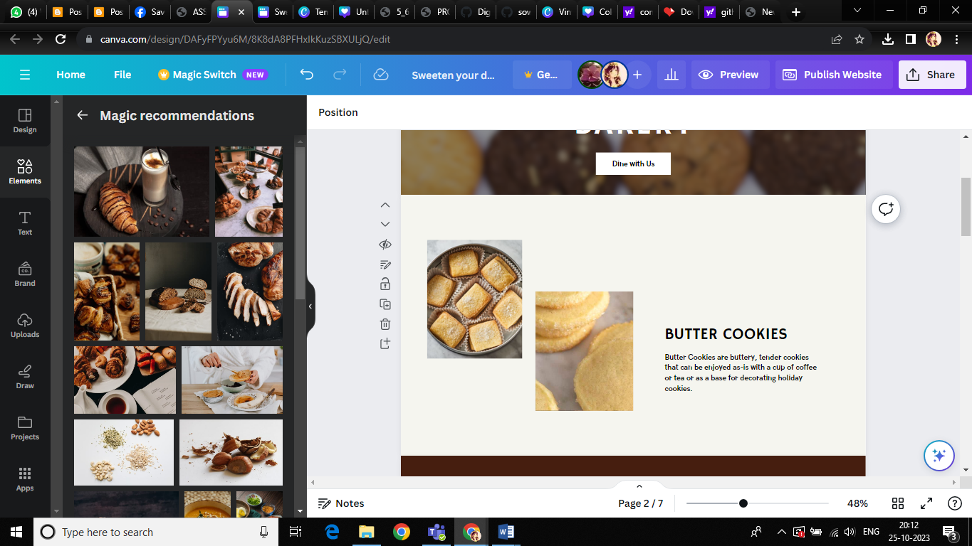

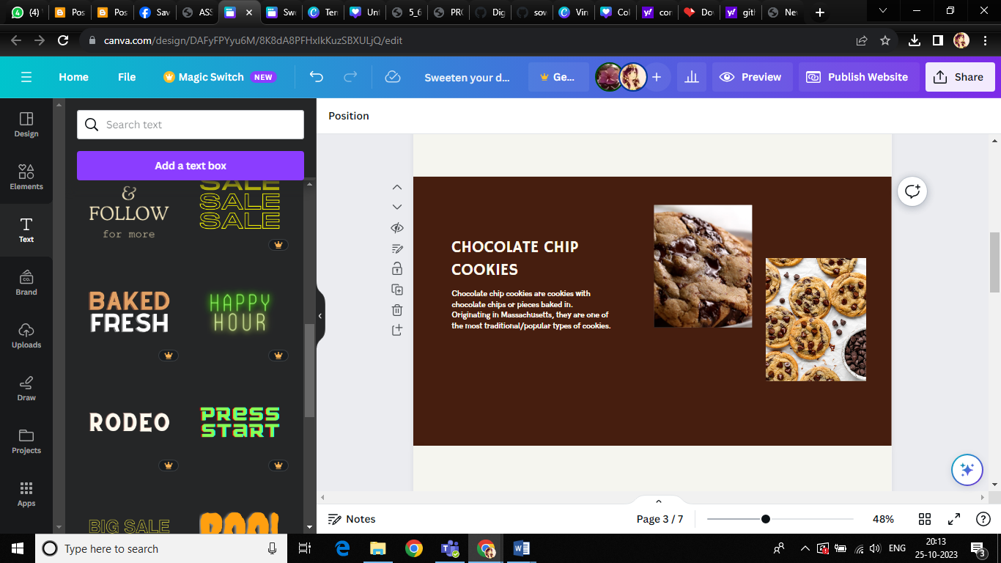

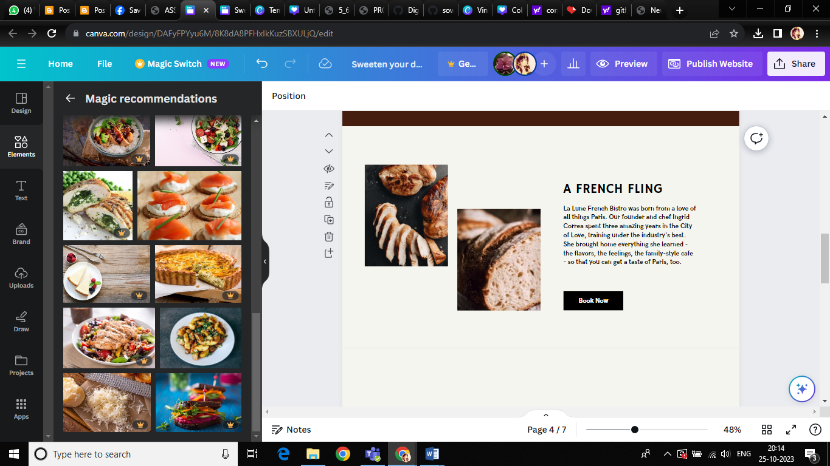

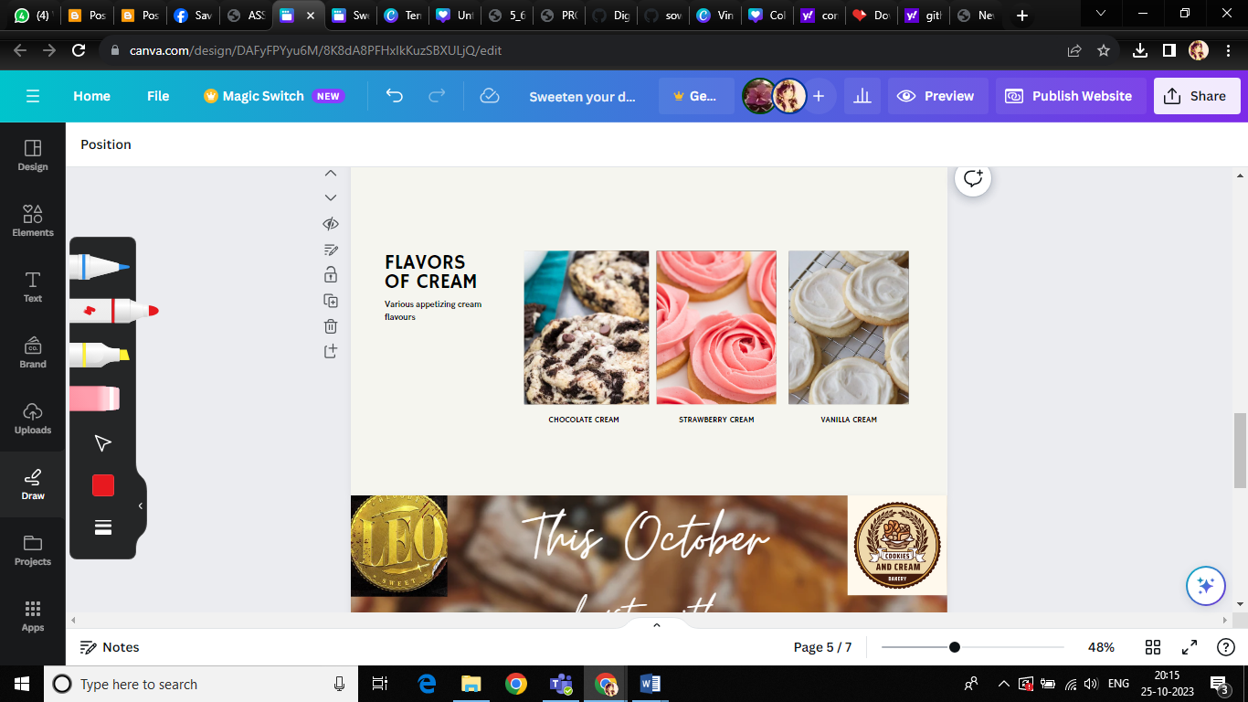

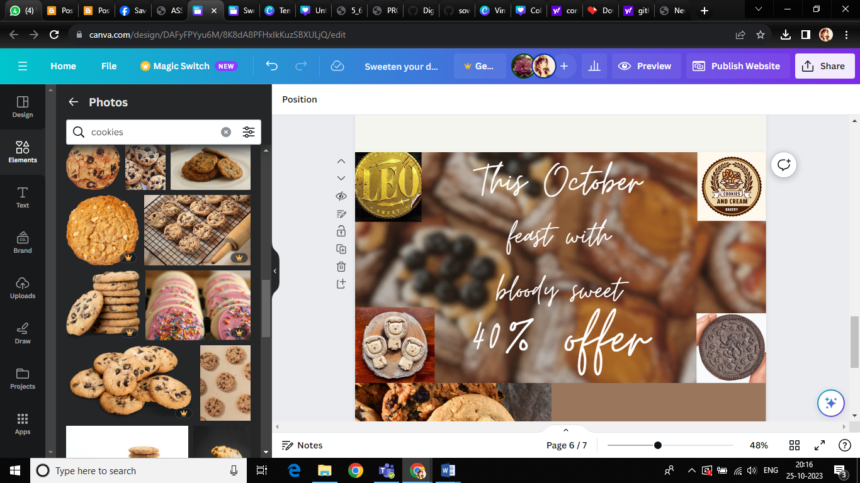

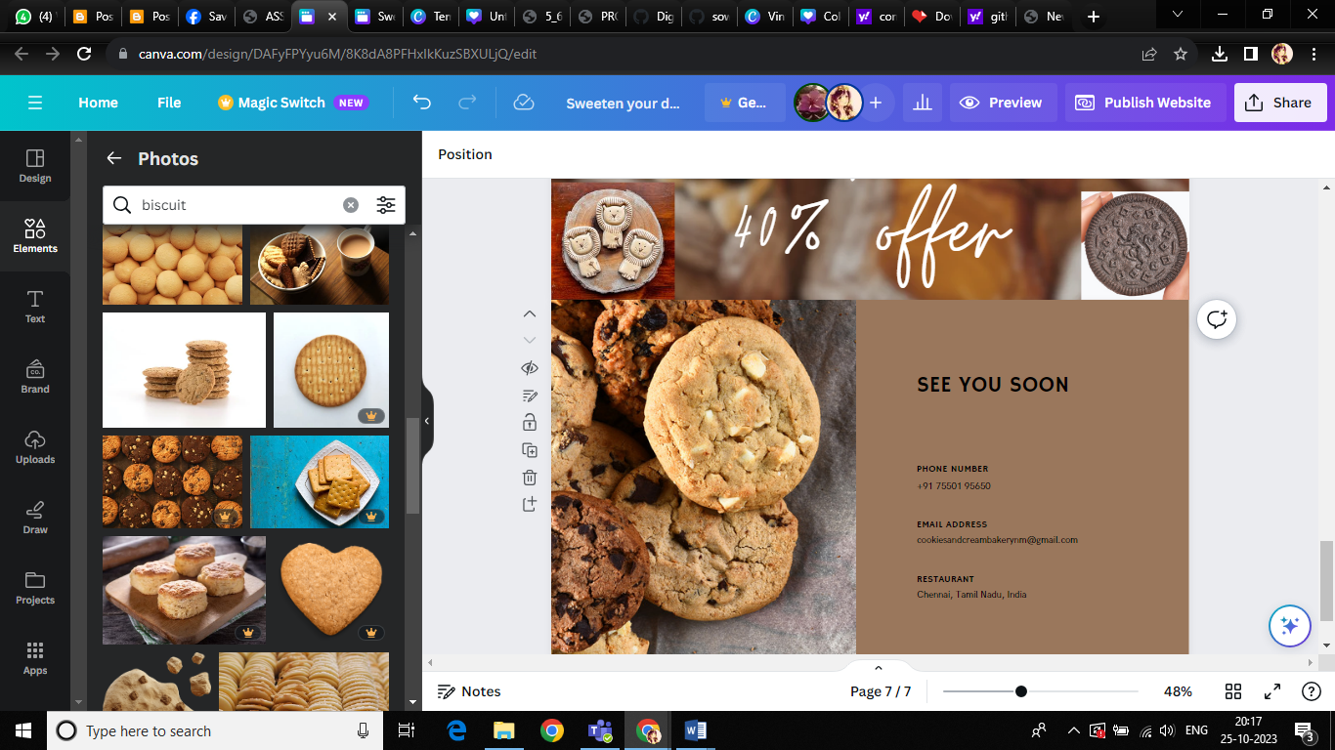

**PUBLISH WEBSITE**

**PUBLISH AND VISIT SITE**

Click Publish

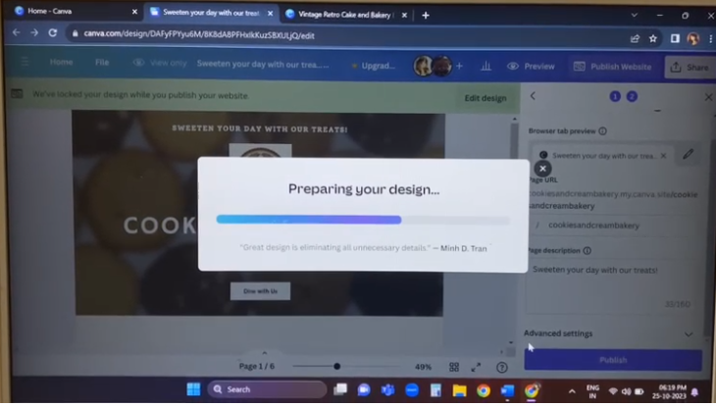

**CLICK "VIEW WEBSITE**

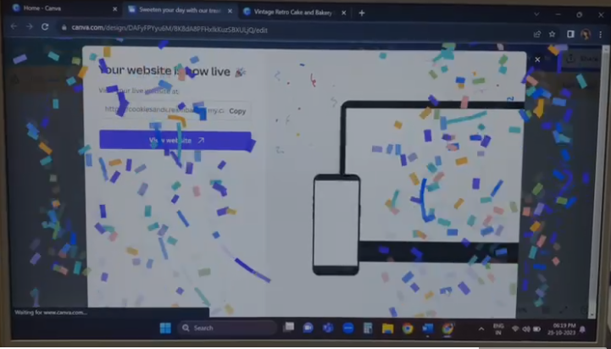

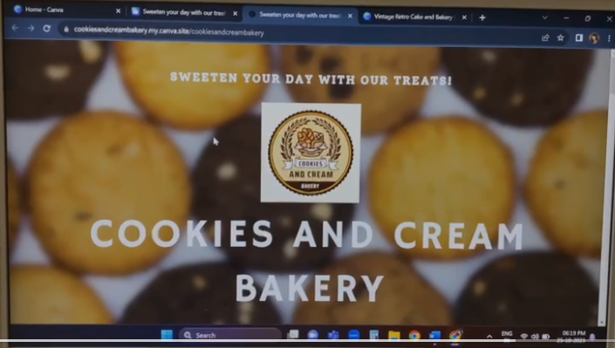

**ADVANTAGES AND DISADVANTAGES**

**ADVANTAGES**

You don’t need to be a skilled designer to start or know anything about design. And it’s because:

* From layout of the platform to guided templates, basically a drag and drop design platform.
* Templates are customisable. You can also create your own designs.

**DISADVANTAGES**

* There is a limitation to template designs and stock photography.
* Intellectual property is ambiguous. You do not own anything, but have usage licensing.

**APPLICATIONS**

### **Share Your Post on Facebook and Drive Paid Traffic.**

* Choose a small daily budget to start with (you can increase the budget later on depending upon the performance of your ad).
* Set your targeting options depending upon whom you want to target your food product to.

**CONCLUSION**

**LEARNING OUTCOME:**

### Create Interesting Food Blogs

### Post Blogs on your Facebook Page and Drive Paid Traffic

### Host an event on social media

### Use Instagram Stories to Promote Your PRODUCTS (Food & Beverages)

### Instagram Influencer Marketing

### Promote Your Reviews Through Facebook and Google Ads

**BRAND NAME:** COOKIES AND CREAM BAKERIES

**CATEGORY:** Butter cookies, Chocolate chip cookies ,flavours of cream

**TARGET AUDIENCE:** ALL (Men, Woman, Youths, Teens, Kids, Babies)

**CANVA WEBSITE URL:** <https://cookiesandcreambakery.my.canva.site/cookiesandcreambakery>

**GitHub LINK:** [**https://github.com/sowmiyamurugan123/DIGITAL-MARKETING**](https://github.com/sowmiyamurugan123/DIGITAL-MARKETING)

**RECORDED VIDEO DRIVE LINK:**

[**https://drive.google.com/file/d/1C4PNYYW4UJnuPcHoBeZ_kbeV4W2OaoUS**](https://drive.google.com/file/d/1C4PNYYW4UJnuPcHoBeZ_kbeV4W2OaoUS)